Business Template

Subject areas
Logo / Image

Contents
1 Business Description 3
1.1 Business background 3
1.2 Problems. Current Situation 3
1.3 The benefits of implementing a database. Project Vision 3
2 Model description 3
2.1 Definitions & Acronyms 3
2.2 Logical Scheme 3
2.3 Objects 3

Business Description

Business background
An Auction House is a business that organizes and facilitates the sale of goods or services through a public auction process. Typically, the auction house serves as an intermediary between sellers (who wish to auction their goods) and buyers (who are interested in bidding for the items). The goal of an auction house is to sell items to the highest bidder in a competitive environment. This process can involve both physical auctions, where buyers and sellers gather in a venue, and online auctions, where bids are made over the internet.

Problems. Current Situation
An Auction House, like any business, faces various challenges in its operations. Below are some of the key problems and issues that are commonly encountered in the current situation for an auction house:

1. Inefficient Inventory and Catalog Management
Problem: Auction houses deal with large inventories of items, especially if they conduct multiple auctions or sell diverse categories of items. Managing and cataloging these items manually or through inefficient systems can lead to mistakes, missed items, or inaccurate descriptions, leading to poor customer experiences.
2. Limited Bidding Visibility (Online and In-Person)
Problem: For live (physical) auctions, the bidding process is often limited to those who can attend in person, which restricts the reach and participation. Online bidding may also have limitations, such as not reflecting real-time bids accurately or having a less user-friendly interface.
3. Inefficient Payment and Transaction Processing
Problem: Payment collection and management can be slow and cumbersome, especially when dealing with multiple payment methods (e.g., credit cards, bank transfers, checks). Delays in processing payments or errors in payment recording can cause frustration and financial discrepancies.
4. Lack of Proper Customer Relationship Management (CRM)
Problem: Auction houses may not have a centralized system to manage bidder and seller relationships, which can result in lost opportunities for repeat business. Without a proper CRM system, it's hard to track bidders’ preferences, past purchases, or follow up on potential leads.
5. Poor Auctioneer and Item Association
Problem: Auction houses often struggle with efficiently matching auctioneers to specific items. Auctioneers specialize in different types of items, and an incorrect pairing can reduce the quality of the auction and affect item sales.
6. Difficulty in Managing Many-to-Many Relationships (Auction, Item, and Bidders)
Problem: A complex many-to-many relationship exists between auction items, bidders, and auctions themselves. For example, multiple items can be part of the same auction, multiple bidders can bid on the same item, and bidders can participate in multiple auctions. Managing these relationships can become cumbersome and prone to errors.
7. Lack of Effective Marketing and Customer Engagement
Problem: Auction houses often fail to effectively market upcoming auctions or engage potential customers. Relying solely on word-of-mouth or outdated marketing strategies (e.g., printed catalogs or email blasts) can limit the exposure of items and reduce overall attendance and bidding.
8. Insufficient Analytics and Reporting
Problem: Auction houses often lack the ability to gather detailed analytics and reporting on auction performance, bidder behavior, and financial transactions. Without this data, auction houses may struggle to make informed decisions regarding inventory, pricing strategies, or marketing efforts.
9. Security and Fraud Prevention Issues
Problem: Auction houses, especially online platforms, face risks related to security and fraud. Bidders could place fraudulent bids, payment processing might be vulnerable to hacking, or there could be disputes regarding the authenticity of the auction items.
10. Logistics and Shipping Management
Problem: After an auction, the auction house must manage logistics for delivering sold items to buyers. Shipping can become complicated if items are large, fragile, or international. Delays in delivery or errors in shipping details can damage the auction house’s reputation.

the Benefits of implementing a database. Project Vision
Implementing a well-designed database for an Auction House offers numerous benefits that can streamline operations, enhance efficiency, and improve customer satisfaction. Below are the key benefits of implementing a database and the vision for this project:

- Benefits of Implementing a Database
- Centralized Data Management:
- Improved Efficiency and Automation:
- Enhanced Data Integrity:
- Better Tracking and Reporting:
- Real-time Updates:
- Scalable and Flexible System:
- Improved Customer Relationship Management (CRM):
- Enhanced Security and Fraud Prevention:
- Efficient Payment and Transaction Processing:
- Optimized Inventory Management.
Project Vision
The vision for implementing a database for the Auction House is to create a comprehensive, automated, and efficient system that supports all aspects of the auction process, from item cataloging and bidding to payment processing and customer management. This system will:
- Simplify Operations: Automate manual tasks, reducing the chances for error and making the auction process more streamlined.
- Enhance Customer Experience: Provide bidders and sellers with easy access to real-time auction data, improving engagement and satisfaction.
- Enable Data-Driven Decisions: Equip auction house managers with actionable insights through analytics, allowing for smarter decision-making and better strategic planning.
- Promote Growth and Scalability: Build a system that can easily scale with the business as the auction house grows, supporting more auctions, items, and customers.
- Ensure Data Security: Implement robust security measures to protect sensitive data and maintain trust with customers.
- Facilitate Efficient Collaboration: Enable auctioneers, bidders, and sellers to collaborate seamlessly through a unified platform.

Model description

Definitions & Acronyms
Auction: An event where items are sold to the highest bidder. Auctions can be live (in-person) or conducted online.

Bidder: An individual or entity participating in an auction by placing bids on items they are interested in purchasing.

Item: The object or asset being auctioned in an auction event. Items could include artwork, antiques, collectibles, cars, etc.

Auctioneer: The person responsible for managing the auction process, including calling bids, managing the event, and ensuring a smooth flow of the auction.

Category: A classification for items being auctioned, such as art, antiques, jewelry, vehicles, etc.

Bid: The amount of money offered by a bidder for an item in the auction.

Payment: The financial transaction made by a winning bidder to the auction house after winning an auction item.

Auctioneer_Item: A table that represents the many-to-many relationship between auctioneers and items. It tracks which auctioneer is associated with which items.

Auction_Item: A table that captures the many-to-many relationship between auctions and items, identifying which items are part of which auction event.

Address: The location information associated with either a bidder or auctioneer, including details like street address, city, state, and country.

Item_Description: A detailed description of the item being auctioned, providing more context about the item, such as condition, origin, and special features.

Payment Status: The status of the payment made by the bidder. It could be "Pending", "Completed", "Failed", or "Refunded".

Logical Scheme
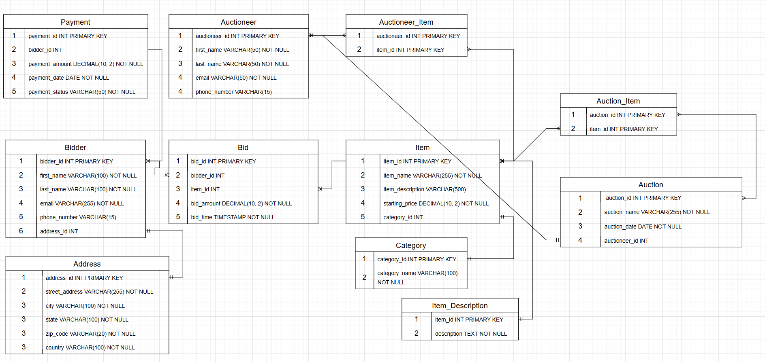

Objects

Table Description
<description>

Table Name | Field name | Field Description | Data Type
Auction | auction_id | Unique identifier for each auction event. | Int
 | auction_name | Name of the auction event (e.g., "Spring Art Auction"). | VARCHAR(255)
 | auction_date | Date and time when the auction will take place. | auction_date
 | location | Physical location of the auction (if applicable). | VARCHAR(255)
 | auction_type | Type of auction (e.g., "Live", "Online"). | VARCHAR(50)
Item | item_id | Unique identifier for each item. | INT
 | item_name | Name or title of the item. | VARCHAR(255)
 | category | Category or type of the item (e.g., "Art", "Jewelry"). | VARCHAR(100)
 | description | Detailed description of the item. | TEXT
 | starting_bid | Starting price for the item. | DECIMAL(10, 2)
 | reserve_price | Minimum price that must be met for the item to sell. | DECIMAL(10, 2)
 | status | Minimum price that must be met for the item to sell. | VARCHAR(50)
Bidder | bidder_id | Unique identifier for each bidder. | INT
 | first_name | First name of the bidder. | VARCHAR(100)
 | last_name | Last name of the bidder. | VARCHAR(100)
 | email | Contact email address of the bidder. | VARCHAR(255)
 | phone_number | Contact phone number of the bidder. | VARCHAR(20)
 | address | Mailing address of the bidder. | VARCHAR(255)
Bid | bid_id | Unique identifier for each bid. | INT
 | bidder_id | Reference to the bidder who placed the bid. | INT
 | item_id | Reference to the item being bid on. | INT
 | bid_amount | The amount placed for the bid. | DECIMAL(10, 2)
 | bid_time | The timestamp when the bid was placed. | DATETIME
Payment | payment_id | Unique identifier for each payment. | INT
 | bidder_id | Reference to the bidder who made the payment. | INT
 | auction_id | Reference to the auction in which the payment is made. | INT
 | payment_amount | The total amount paid by the bidder. | DECIMAL(10, 2)
 | payment_date | Date and time when the payment was made. | DATETIME
 | payment_status | The status of the payment (e.g., "Completed", "Pending"). | VARCHAR(50)
Auctioneer | auctioneer_id | Unique identifier for each auctioneer. | INT
 | first_name | First name of the auctioneer. | VARCHAR(50)
 | last_name | Last name of the auctioneer. | VARCHAR(50)
 | email | Contact email address of the auctioneer. | VARCHAR(50)
 | phone_number | Contact phone number of the auctioneer. | VARCHAR(20)
Auctioneer_Item | auctioneer_id | Reference to the auctioneer. | INT
 | item_id | Reference to the item being handled by the auctioneer. | INT
Address | Address_id | Unique identifier for each address. | INT
 | Street_address | Street name. | VARCHAR(255)
 | city | City name. | VARCHAR(100)
 | state | State | VARCHAR(100)
 | Zip_code | Zip Code | VARCHAR(20)
 | country | Country | VARCHAR(100)

Comments on table relationships

Example with data

auction_id | auction_name | auction_date | location | auction_type
1 | Spring Art Auction | 2025-04-15 18:00:00 | New York City | Live

item_id | item_name | category | description | starting_bid | reserve_price | status
1 | Picasso Painting | Art | An original Picasso painting | 10000.00 | 15000.00 | Available
2 | Diamond Necklace | Jewelry | A 3-carat diamond necklace | 5000.00 | 7000.00 | Available
3 | Vintage Watch | Jewelry | A vintage Rolex watch from 1980s | 2000.00 | 3000.00 | Sold

bidder_id | first_name | last_name | email | phone_number | address
1 | John | Doe | john.doe@email.com | 123-456-7890 | 123 Elm St, NY, USA
2 | Jane | Smith | jane.smith@email.com | 987-654-3210 | 456 Oak St, LA, USA

bid_id | bidder_id | item_id | bid_amount | bid_time
1 | 1 | 1 | 12000.00 | 2025-04-10 15:30:00
2 | 2 | 2 | 5500.00 | 2025-04-11 16:00:00
3 | 1 | 3 | 2500.00 | 2025-04-12 18:00:00

payment_id | bidder_id | auction_id | payment_amount | payment_date | payment_status
1 | 1 | 1 | 12000.00 | 2025-04-15 17:00:00 | Completed
2 | 2 | 2 | 5500.00 | 2025-11-20 13:00:00 | Pending

auctioneer_id | first_name | last_name | email | phone_number
1 | Alice | Johnson | alice.johnson@email.com | 555-123-4567
2 | Bob | Brown | bob.brown@email.com | 555-234-5678

auctioneer_id | item_id
1 | 1
1 | 2
2 | 3

